SAP Integration Suite
Cloud Integration

Technical Specification Document

GSAP_MaterialMaster_DataPro

Version: 1.0
Author: Generated by AI
Date: May 01, 2026
Status: Draft

Table of Contents
1. Change History
1.1 Document Control
2. Overview
2.1 Executive Summary
2.2 Purpose
2.3 Interface Requirement
2.5 Integration Snapshot
3. High level iFlow Design
3.1 Current Scenario
3.2 To-Be Scenario
3.3 High Level Design
3.4 Technical Dependencies
4. Message Flow
4.1 Process Flow
4.2 Message Flow Connections
4.3 Integration Flow Diagram
5. Technical Description
5.1 Main Integration Process
5.3 Sender
5.4 Receiver
5.5 Mappings
5.6 Security
5.7 Groovy Scripts
5.8 Error Handling & Logging
6. Version and Metadata
7. Appendix
7.1 Technical Artifacts
7.2 Schemas
7.3 Externalized Parameters

1. Change History
Version | Date | Author | Description
1.0 | 2026-05-01 | Generated by AI | Initial autogenerated version

1.1 Document Control
- Document ID: TS-GSAP_MaterialMaster_DataPro
- Integration Flow: GSAP_MaterialMaster_DataPro
- Generated On: 2026-05-01 00:53
- Generation Mode: Batch
- Diagrams Included: Yes
- Functional Spec Context: Provided

2. Overview

2.1 Executive Summary
Technical specification for integration flow GSAP_MaterialMaster_DataPro.

2.2 Purpose
This document describes design and implementation details for the integration flow.

2.3 Interface Requirement
Business requirement is captured through source-to-target system integration.

2.5 Integration Snapshot
Metric | Value
Integration Processes | 1
Message Flows | 2
Sequence Flows | 8
Groovy Scripts | 2
Schemas | 0
Externalized Parameters | 37

3. High level iFlow Design

3.1 Current Scenario
Current scenario details are not explicitly configured in the iFlow.

3.2 To-Be Scenario
The integration automates message processing between source and target landscapes.

3.3 High Level Design
The integration is implemented using SAP CI with adapter-based communication.

3.4 Technical Dependencies
- Runtime platform: SAP CI integration flow 'GSAP_MaterialMaster_DataPro' orchestrates message exchange from gSAP to DataPro.
- Inbound interface dependency: path /GSAP/MATMAS_MATMAS05_ZX_MATMAS05; ProcessDirect adapter using Not Applicable over Not Applicable.
- Outbound interface dependency: URL DataPro_PricingCondition; receiver authentication type Not configured with credential/security artifact DataPro_PricingCondition.
- Security dependency: receiver authentication type Not configured with credential/security artifact DataPro_PricingCondition.
- Design-time artifacts: WSDLs src\main\resources\wsdl\MATMAS.MATMAS05.ZX_MATMAS05.wsdl; src\main\resources\wsdl\MT_Insert_MaterialMaster.wsdl | mappings src\main\resources\mapping\mm_MATMAS_MATMAS05_to_MaterialMaster.mmap.
- Custom script artifacts: Interface_Generic_Headers.groovy; Log_Payload.groovy.
- Externalized runtime dependencies: 37 parameter(s) supplied, including BusinessObject.

4. Message Flow
A message comes from gSAP into SAP CI through the configured sender channel.
SAP CI processes the payload and sends the final message to DataPro through the receiver channel.

4.2 Message Flow Connections
Connection | Name
End Message -> DataPro | Datapro_MaterialMaster_JDBC_Receiver
gSAP -> Start | ProcessDirect

4.3 Integration Flow Diagram
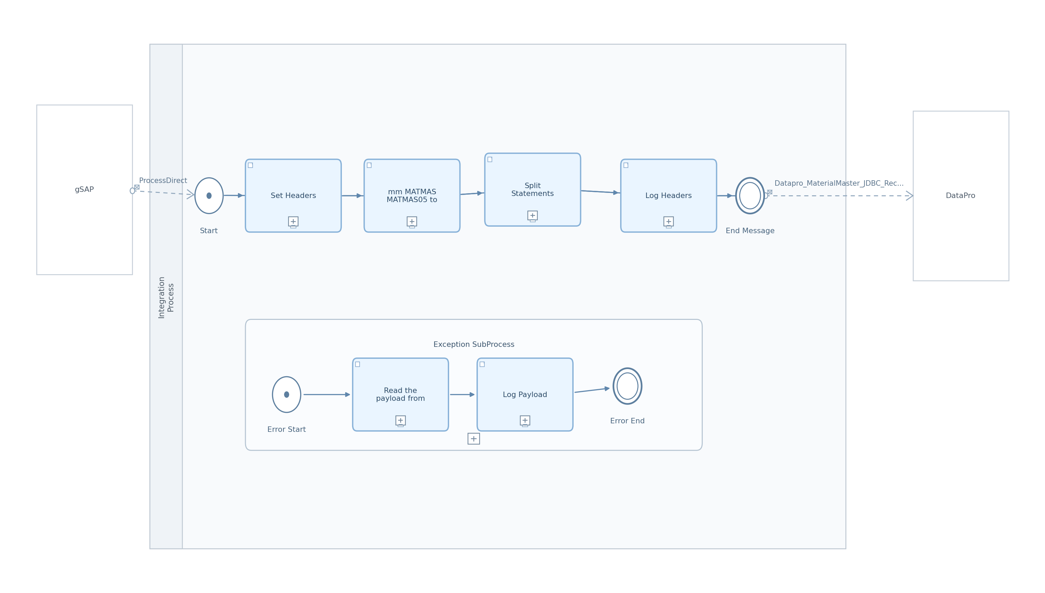
Figure: Integration Flow Diagram

5. Technical Description

5.1 Main Integration Process
Process Name | Sequence Flows | Flow Elements
Integration Process | 8 | 7

Integration Process
This process contains 8 sequence flow(s). Key activities include Exception SubProcess, Log Headers, Set Headers, Split Statements.
Key Activity
Exception SubProcess
Log Headers
Set Headers
Split Statements
mm_MATMAS_MATMAS05_to_MaterialMaster

Step | Description
1 | Log Payload is executed within the process flow.
2 | Read the payload from property is executed within the process flow.
3 | Log Headers is executed within the process flow.
4 | Set Headers is executed within the process flow.
5 | mm_MATMAS_MATMAS05_to_MaterialMaster is executed within the process flow.
6 | Split Statements is executed within the process flow.

Key | Value
Transaction Timeout | 30
Transactional Handling | Not Required

callActivity Set Headers Properties
Key | Value
Body Type | constant

callActivity Split Statements Properties
Key | Value
Split Expr Value | //Statement

5.3 Sender
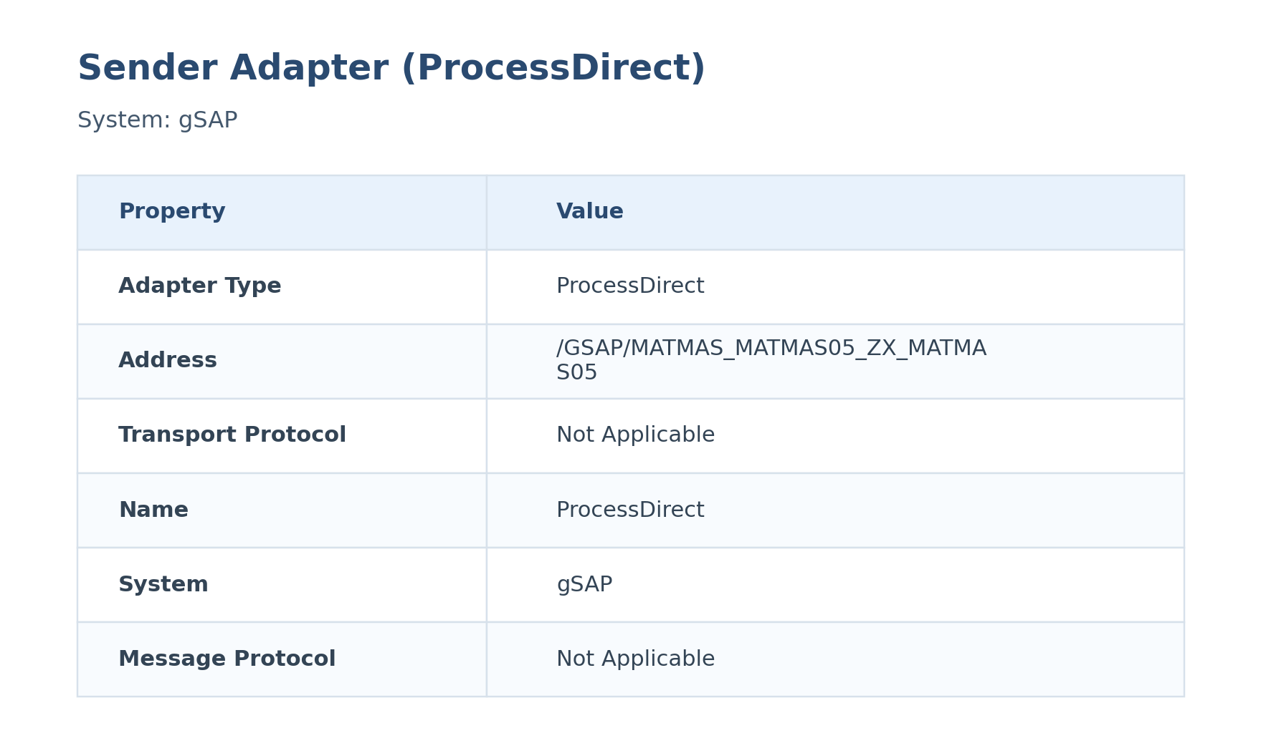
Figure: Sender Configuration

The ProcessDirect sender adapter receives messages from gSAP. It listens on /GSAP/MATMAS_MATMAS05_ZX_MATMAS05. It uses Not Applicable over Not Applicable for inbound communication.
Attribute | Value
Path / Address | /GSAP/MATMAS_MATMAS05_ZX_MATMAS05
Adapter Type | ProcessDirect
Protocol | Not Applicable over Not Applicable
Auth Type | Not configured
User Role | Not configured

5.4 Receiver
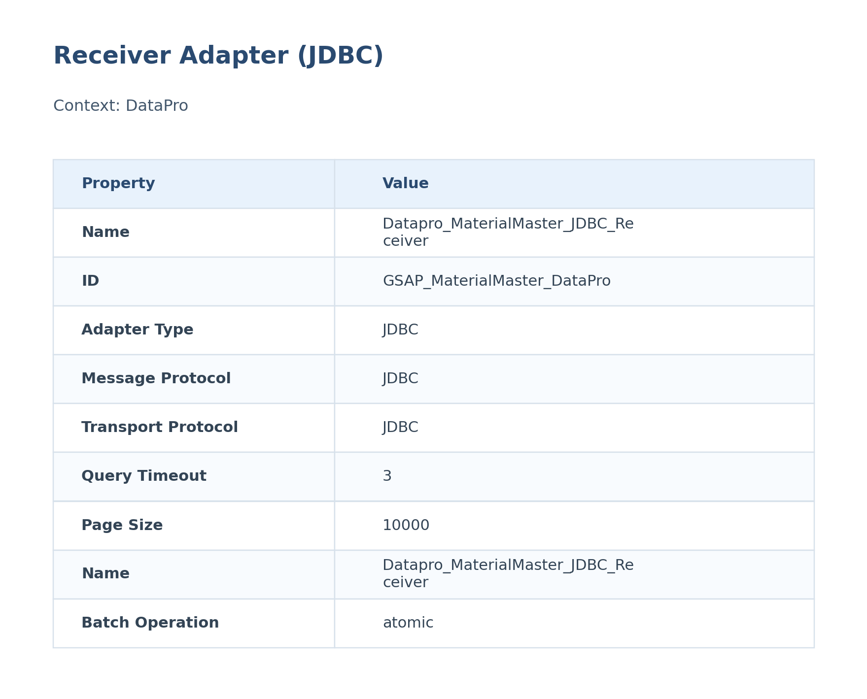
Figure: Receiver Configuration

The JDBC receiver adapter sends processed messages to DataPro. It targets DataPro_PricingCondition. It uses credential/security artifact DataPro_PricingCondition.
Attribute | Value
URL / Address | DataPro_PricingCondition
Adapter Type | JDBC
Authentication Type | Not configured
Credential / Security Artifact | DataPro_PricingCondition
Operation Name | Not configured

5.5 Mappings

mm_MATMAS_MATMAS05_to_MaterialMaster
This mapping transforms MATMAS MATMAS05 data into the MaterialMaster structure used later in SAP CI.
It is executed during message processing to reshape the payload before the next handoff.
Attribute | Value
Source Message / Object | MATMAS MATMAS05
Target Message / Object | MaterialMaster
Mapping File | src\main\resources\mapping\mm_MATMAS_MATMAS05_to_MaterialMaster.mmap

5.6 Security
Key | Value
Http Session Handling | None
Return Exception To Sender | false
Log | All events
Cors Enabled | false
Server Trace | false
Access Control Allow Credentials | false

5.7 Groovy Scripts

Interface_Generic_Headers.groovy
Interface_Generic_Headers.groovy is used within the integration flow. It imports 1 module(s).
[Groovy]
import com.sap.gateway.ip.core.customdev.util.Message;
def Message processData(Message message)
{
def messageLog = messageLogFactory.getMessageLog(message);
if(messageLog != null)
{
def Country = message.getHeaders().get("Country");
if(Country!=null)
{
messageLog.addCustomHeaderProperty("Country", Country);
}
def Region = message.getHeaders().get("Region");
if(Region!=null)
{
messageLog.addCustomHeaderProperty("Region", Region);
}
def BusinessObject = message.getHeaders().get("BusinessObject");
if(BusinessObject!=null)
{
messageLog.addCustomHeaderProperty("BusinessObject", BusinessObject);
}
def Sender = message.getHeaders().get("Sender");
if(Sender!=null)
{
messageLog.addCustomHeaderProperty("Sender", Sender);
}
def Receiver = message.getHeaders().get("Receiver");
if(Receiver!=null)
{
messageLog.addCustomHeaderProperty("Receiver", Receiver);
}
def TimeStamp = message.getHeaders().get("TimeStamp");
if(TimeStamp!=null)
{
messageLog.addCustomHeaderProperty("TimeStamp", TimeStamp);
}
def MaterialNumber = message.getHeaders().get("MaterialNumber");
if(MaterialNumber!=null)
{
messageLog.addCustomHeaderProperty("MaterialNumber", MaterialNumber);
}
def IDocNumber = message.getHeaders().get("IDocNumber");
if(IDocNumber!=null)
{
messageLog.addCustomHeaderProperty("IDocNumber", IDocNumber);
}
}
return message;
}

Log_Payload.groovy
Log_Payload.groovy is used within the integration flow. It imports 2 module(s).
[Groovy]
import com.sap.gateway.ip.core.customdev.util.Message;
import java.util.HashMap;
def Message processData(Message message) {
def body = message.getBody(java.lang.String) as String;
def messageLog = messageLogFactory.getMessageLog(message);
messageLog.addAttachmentAsString("Output", body, "text/plain");
return message;
}

5.8 Error Handling & Logging

Exception SubProcess Diagram
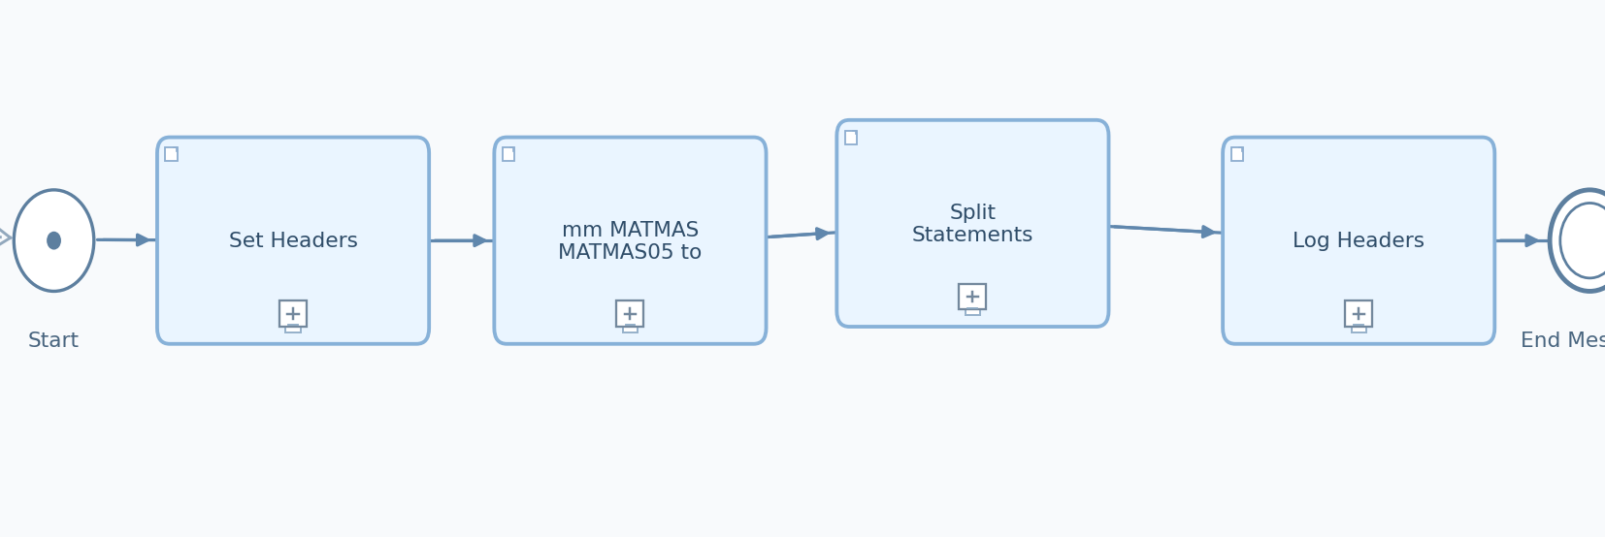
Figure: Exception SubProcess (Copied from Integration Flow Diagram)

Exception SubProcess 1 Properties

Child Element: callActivity Log Payload
Key | Value
subActivityType | GroovyScript
script | Log_Payload.groovy

Child Element: callActivity Read the payload from property
Key | Value
bodyType | expression
wrapContent | ${property.InputPayload}

6. Version and Metadata
Key | Value
Componentversion | 1.3

7. Appendix

7.1 Technical Artifacts
- iFlow: GSAP_MaterialMaster_DataPro.iflw
- Groovy Script: Interface_Generic_Headers.groovy
- Groovy Script: Log_Payload.groovy
- Message Flows: 2
- Sequence Flows: 8
- Mapping Activities: 1

7.3 Externalized Parameters
Parameter | Value | Used In
BatchMode | false | Receiver - Batch Mode
ConnectionTimeout | 3 | Receiver - Connection Timeout
JDBCDataSourceAlias | DataPro_PricingCondition | Receiver - Alias
MaximumRecords | 10000 | Receiver - Page Size
Query/ResponseTimeout | 3 | Receiver - Query Timeout
Sender_Address | /GSAP/MATMAS_MATMAS05_ZX_MATMAS05 | Sender - Address

